National University of Computer and Emerging Sciences, Lahore Campus
Course: | Operating Systems | Course Code: | CS2006
Program: | BS | Semester: | 4
Section: | CS | Total Marks: | 50
Submission deadline: | 28-2-2025 | Weight | 3.3
Assignment:1 |  | Page(s): | 2
Instruction
- Understanding of the problems is part of the assignments. So, no query please.
- You will get Zero marks if found any type of cheating.
- 25 % deduction of over marks on the one-day late submission after due date
- MUST BE HANDWRITTEN.
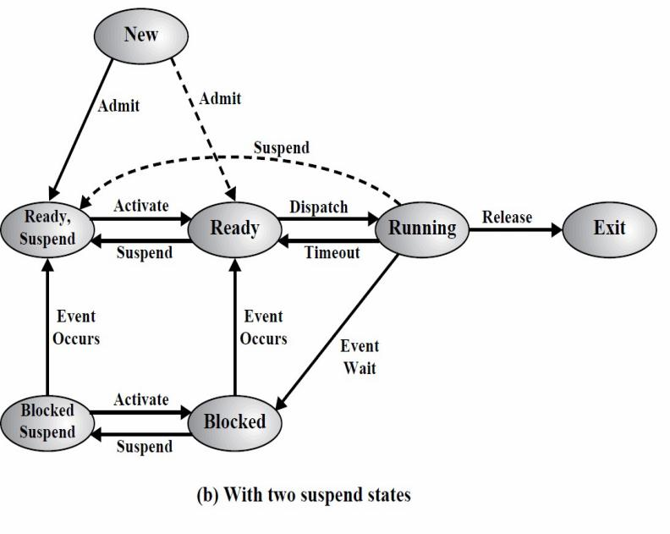
Question: 1-State all the two newly added States and their respective transitions in 7-state process model shown below in figure, also mention which scheduler will be responsible for doing the state change from one to other. As per our class discussion, medium term scheduler is responsible for SWAP IN and SWAP OUT (Swapping), After SWAP OUT which process will get the higher priority to SWAP IN back to the Ready queue or blocked queue and why? Justify your answer.
Question:2- Consider the following C program which is executed on a Unix/Linux system, what will be the output of the following code? Justify your answer by making tree structure.
if (fork() && fork())  {  fork();  }  if (fork() || fork())  {  fork();  }  printf("OS");  return 0; | - How many times String “OS” will be printed?  b- How many total number of child processes will be created by the above program? Justify your answers by making Process tree.

Question 3: Parallel Sorting with fork() and exec()
Write a C program that splits an array into two halves and creates two child processes using fork(). Each child process should sort one half of the array using the exec() function to run an external sorting program (e.g., an external bubble sort program). The parent process should merge the two sorted halves once both child processes have completed. Both your child processes should use different sort functions. Child Process 1 should implement Merge Sort and Child Process 2 should implement Insertion Sort.

Question 4: Program to Perform Matrix Addition using fork() and pipes
Write a C program to perform matrix multiplication with the help of child processes (using fork()) and pipes.
Assume you are given two square matrices A and B of size n x n. Your task is to compute matrix C which is the sum matrix of A and B. The parent process will fork n child processes. Each child will compute one row of matrix C and will send their rows to the parent process using pipes. The parent process will simply compile this rows into the final matrix C and display it.

Question 5: Executing External Programs with exec() and fork()
Write a C program using Linux system calls to create two child processes using the fork() system call. The first child process should use execlp() and execute the cat command to display the contents of a file passed as a command-line argument. After the first child process completes, the parent process should create a second child process, which should again call execlp command to execute the wc command to count the number of lines, words, and characters in the same file.
Question 6: Finding Prime Numbers in a Range Using Child Process using pipes
Write a C program where the parent process takes a range of numbers as input. The parent creates two child processes using fork() .The first child process finds and prints all prime numbers in the lower half of the range. The second child process finds and prints all prime numbers in the upper half of the range. Use proper inter-process communication via pipes to send the range from the parent to both child processes and collect the results back from them.

Question 7: Reading and writing through FIFO system call
Write a C program that uses two processes to communicate via a named pipe (FIFO). The writer process should read input from the terminal and send it through the pipe. The reader process should read the data from the pipe, display the received message, and count the number of words in the message. Display both the message and the word count on the screen.

Instructions for questions 3-7:
You can submit either a printout or a handwritten copy of your Linux terminal code, along with a screenshots of the output for each question. Make sure your output terminal user name is the same as yours.

